**Updated RBS, WBS and time estimating**

**Project name: Diagnosis of diabetes retinopathy**

**Updated RBS**

1. **Data Input and Enhancement Processing**

**1.1Image Standardization**: Normalize input images to ensure data consistency.

**1.2Noise Removal**: Apply image processing techniques to reduce noise and improve image quality.

**1.3Pixel-level Annotation**: Perform fine-grained annotation of lesion areas to facilitate model training.

**1.4Brightness Adjustment**: Optimize image brightness to enhance feature discernibility.

1. **Deep Learning-Based Lesion Grading Detection Algorithm**

**2.1Model Selection and Training**: Select appropriate deep learning models (e.g., ResNet) and train them for retinal lesion identification.

**2.2Lesion Grading Algorithm**: Develop a lesion grading algorithm with ≥85% accuracy and ≥80% recall rate.

1. **Automated Detection Report Generation**

**3.1Condition Analysis**: Analyze test results to provide health guidance and recommendations.

**3.2Report Generation**: Generate diagnostic reports including lesion location, severity, and treatment suggestions for physician review.

1. **User Interface**

**4.1Physician Interface**：View patient test results, lesion grading, and treatment recommendations. Support image upload, result visualization, and report export functions.

**4.2Patient Interface**：Provide test result queries, treatment suggestion display, and health management features.

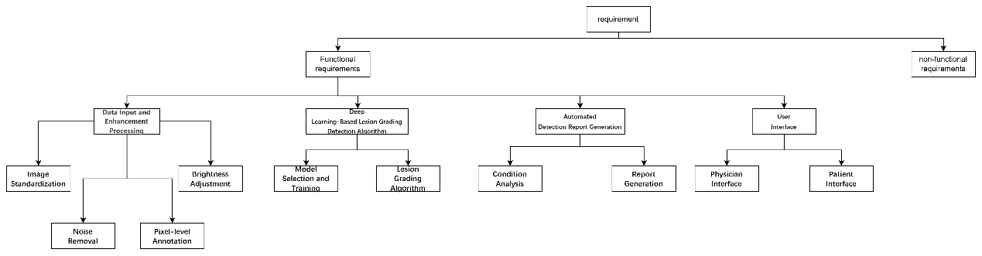

**Updated WBS**

**Part I Overall project task**

**1. Project Management**

1.1 Project Initiation & Planning

Develop project charter

Requirements analysis & scope definition

Create project plan (timeline, budget, resources)

1.2 Progress & Quality Control

Milestone setting & tracking

Quality assurance & testing plan

**2. Data Preparation**

2.1 Data Collection

Acquire retinal image datasets (public/hospital partnerships)

Data anonymization & privacy processing

* 1. Data Preprocessing

**3. Algorithm Development**

* 1. Model Design & Training

**Model selection** (comparative testing of ResNet, EfficientNet, etc.)

**Model training** (GPU cluster deployment, hyperparameter tuning)

* 1. Lesion Grading Algorithm

Grading criteria definition

Multiclass model development (accuracy ≥85%)

3.3 Performance Optimization

Inference speed optimization (model pruning/quantization)

Recall rate improvement (data augmentation/loss function refinement)

**4. System Development**

* 1. Core Modules

**Image analysis engine** (integrated trained model)

**Report generation module** (automated PDF templates)

* 1. User Interfaces

**Physician Portal**

Patient management dashboard

Image upload & result visualization

Report editing/export

**Patient Portal**

Test result queries

Personalized health recommendations

4.3 System Integration

Frontend-backend API development

Database design (patient information storage)

**5. Testing & Deployment**

5.1 Validation

**Unit testing** (algorithm module verification)

**Clinical trials** (pilot testing at partner hospitals)

5.2 Deployment

Server configuration (high-concurrency support)

Security implementation (data encryption/access control)

**Part II Time estimating (Refer to the previous assignment)**

|  |  |  |  |  |
| --- | --- | --- | --- | --- |
| **Task** | **Start Date** | **End Date** | **Duration (Days)** | **Workload (Hours)** |
| 1. Develop a project plan | 3.24 | 3.28 | 5 | 5 |
| 2.1 Collecting retinal image data | 3.29 | 4.2 | 5 | 5 |
| 2.2 Data cleaning and preprocessing | 4.3 | 4.9 | 7 | 15 |
| 2.3 Data augmentation | 4.10 | 4.15 | 6 | 20 |
| 3.1.1 Choose a deep learning model | 4.3 | 4.15 | 13 | 15 |
| 3.1.2 Model Training and Validation | 4.16 | 5.16 | 31 | 30 |
| 4. Front-end & Report Integration | 5.2 | 5.16 | 15 | 20 |
| 5.1 Unit Testing | 5.17 | 5.26 | 10 | 20 |
| 5.2 System Integration Testing | 5.27 | 6.5 | 10 | 20 |
| 5.3 User Acceptance Testing | 6.6 | 6.10 | 5 | 20 |
| 6. Overall project management | 3.24 | 6.15 | 84 | 10 |
| Total estimate | \ | \ | 84 | 180 |

